Top of Form

Queen’s University Simulation Scenario Template

Course: | SR Resus Rounds
Case Title: | Organophosphates
Brief Case Description

52 year old man attempts suicide by ingesting 4 x 250mL bottles of Malathion 50% insecticide. Malathion is an organophosphate insecticide that can be purchased at local gardening centres.
The patient demonstrates a cholinergic toxidrome and requires LARGE doses of atropine for reversal. 2PAM is also antidotal.
Searchable Keywords:
- Organophoosphate
- Toxicology
- Cholinergic toxidrome
Target Audience: | FRCP SR Residents
Number of Participants: | 5
CanMeds Roles : |  | Medical Expert |  | Manager |  | Scholar
 |  | Communicator |  | Collaborator |  | Professional
 |  | Health Advocate
Objectives:
- Knowledge | - Understand the pahotphysiology of organophosphate poisonings  - Recognize that the dose of atropine required to treat these patients usually exceeds hospital resources
- Skills | - Atropine delivery with doubling doses
- Behaviour | - Recognize the need for decontamination on scene  - Staff protection
Bottom of Form

Stem: Detailed description of exercise
52 y/o male attempts suicide approximately 30 minutes before presentation by consuming 4x250mL of 50% Malathion insecticide (2x LD50 dose). He presents with a cholinergic toxidrome (Salivation, vomiting, bronchorrhea, bradycardia, altered mental status).
The majority of the resuscitation centers on giving large doses of atropine in doubling doses to control bronchorrhea, and the early administration of 2PAM to prevent the conformational change of the AChe enzyme.
The patient remains hypoxic with significant bronchorrhea until 50mg of atropine are given. The patient’s heart rate improves after 10 mg but should not be the end point of resuscitation.
Transcutaneous pacing doesn’t work (no capture)
Roles: | - RN Confederate  - Worried wife
Script (for each role): | Worried wife:  I found him in the garage with 4 of these bottles empty (hand the bottle of Malathion to the residents). He told me they were for the mosquitos. I believed him. I shouldn’t have. He’s been so sad lately but I didn’t think he’d try to kill himself again. It’s been 3 years since he had any trouble with suicidal thoughts.  He doesn’t have any medical history. He’s healthy. He’s not on any medications. He doesn’t even drink. He’s not diabetic
Scenario Tips:
- Tips to future instructors to keep the scenario flowing.
- Anticipated difficulties

Scenario Details:
Demographics:  - Name:  - Age:  - Sex:  - BMI | Larry McTavish  52  Male
Chief Complaint: | Altered level of consciousness after suicide attempt
Past Medical History: | None
Medications: | None
Allergies: | None
Lab data: (provided if requested) | Normal, except acute respiratory acidosis and profound hypoxia
Imaging: (provided if requested) | Pre-Intubation CXR: CHF/Pulmonary Edema  Post Intubation CXT: Good ETT position, ongoing edema
ECG:  (provided if requested) | Sinus bradycardia

Initial Physical Examination Findings: (Normal if left blank)
Vital signs:
Temperature | 37.2
HR | 39
BP | 82/40
RR | 28
O₂ saturation | 78% RA 88% NRB
Finger stick glucose | 14.8
Weight (kg) | 84
Cardiovascular:
Heart rate/rhythm | Sinus bradycardia @39
Heart sounds | Normal
JVP | Normal
Peripheral pulses | Normal
Evidence of cyanosis? | Yes
Diaphoresis | Yes- Profound
Other
Respiratory:
Respiratory rate/pattern | Tachypnea @ 28
Accessory muscle use? | Yes
Lung sounds | Diffuse coarse inspiratory crackles
Evidence of fatigue? | Yes
Other
Abdominal:
Visible signs of pathology? | Normal
Bowel sounds | Normal
Peritoneal signs? | Normal
Tenderness? | Normal
Hepatosplenomegaly? | Normal
Signs of ascites? | Normal
Other | Vomiting (Stomach contents, and non-bloody diarrhea)
Neurological:
Level of consciousness & Behaviour | Aletered LOC (confused, combative)
Muscle tone | Generalized decreased muscle tone
Motor | Normal
Sensory | Normal
Reflexes | Normal
Other
Head/Ears/Eyes/Nose/Throat/Skin:
Visible abnormalities | Small pupils  frothing from mouth

Flow Table:
Time or Stage: | Arrival | Pre intubation | Post intubation | 10 mg Atropine | 50 mg Atropine
Heart rhythm: | Sinus Brady | Sinus Brady | Sinus Brady | NSR | NSR
Heart rate: | 30 | 30 | 40 | 60 | 70
Heart Sounds: | Normal | Normal | Normal | Normal | Normal
Blood pressure: | 82/40 | 78/38 | 80/40 | 84/50 | 90/60
Respiratory rate: | 28 | 28 | Vent | Vent | Vent
Respiratory Pattern: | Tachypnea | Tachypnea | Vemt | Vent | Vent
O₂ saturation: | 78%RA | 88%NRB | 88%Vent | 88% Vent | 93%Vent
Temperature: | 37.2c | 37.2c | 37.2c | 37.2c | 37.2c
Glucose | 14.8 | 14.8 | 14.8 | 14.8 | 14.8
Eyes: | open | closed | closed | closed | Closed
Pupils: | 2mm | 2 | 2 | 2 | 4
Specific simulator dialogue: | Crackles | Crackles | Crackles | Crackles | No Crackles
Other: | Bronchorrhea

Flow Diagram:
Insert specific scenario flow diagram showing pathways for anticipated actions. Each section of the diagram should correspond to a column on the Flow Table above.
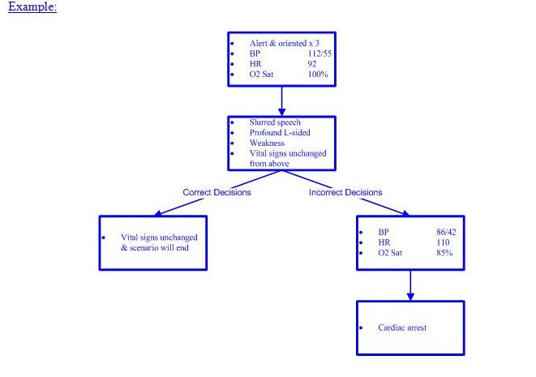

Simulator Requirements:
Environment: |  | ER
 |  | Hospital Ward
 |  | ICU
 |  | Other
Required simulator capabilities: |  | Adult
 |  | Child
 |  | Ability to talk
 |  | Ability to open and close eyes
 |  | Ability to change pupil size
 |  | Output of basic cardiorespiratory rhythms
 |  | Ability to change vital signs
 |  | Ability to perform CPR
 |  | Ability to deliver energy via LifePack
 |  | Ability to gain IV access
 |  | Ability to gain IO access
 |  | Ability to get 12 and 15 lead EKG’s
 |  | Ability to deliver drugs
 |  | Ability to ventilate
 |  | Ability to intubate
 |  | Ability to catheterize
 |  | Ability to needle decompress
 |  | Ability to insert chest tube
 |  | Ability to seize
 |  | Ability to simulate cyanosis
 |  | Other:
Task trainers required: |  | IV access trainer
 |  | IO access trainer
 |  | Lumbar puncture trainer
 |  | Central line access trainer (IJ, femoral, subclavian)
 |  | Chest tube trainer
 |  | Cricothyrotomy trainer
 |  | Pericardiocentesis trainer
 |  | Thoracotomy trainer
 |  | Other:
Communications Equipment: |  | One way wireless (confederate)
 |  | Two way wireless (confederate)
 |  | Overhead Speakers
 |  | Telephone
 |  | Pager
 |  | Other:

Moulage:

Describe any scenario-specific moulage on the diagram below:

Small pupils

Vomit

Diaphoresis (Sweat

Diarrhea

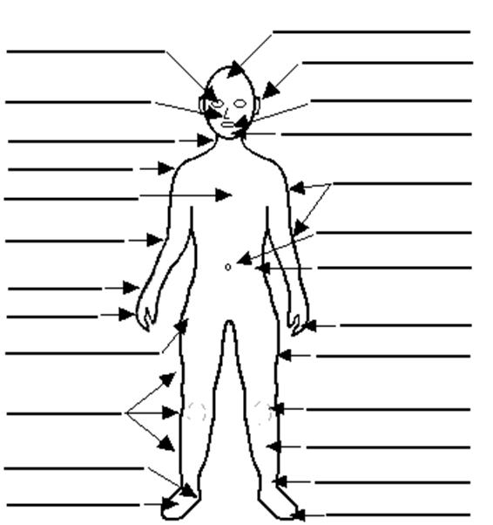

Mannequin Clothing

Hospital gown
Formal work attire
Casual attire
Athletic clothing
Other:

Equipment Required: |  |  |  |  |  | Quantity Required |  | Sizes Required  (if applicable)
Diagnostic/Monitoring: |  |  |  | Portable monitor |  | 1
 |  |  |  | Thermometer |  | 1
 |  |  |  | NIBP |  | 1
 |  |  |  | Defibrillator |  | 1
 |  |  |  | EKG |  | 1
 |  |  |  | CXR |  | 1
 |  |  |  | O₂ saturation probe |  | 1
Airway: |  |  |  | Bag valve mask |  | 1
 |  |  |  | Peak flow meter
 |  |  |  | Nasal cannula |  | 1
 |  |  |  | Nebulizer
 |  |  |  | Non-rebreather mask |  | 1
 |  |  |  | Mechanical ventilator |  | 1
 |  |  |  | Oropharyngeal airway |  | 1
 |  |  |  | Nasopharyngeal airway |  | 1
 |  |  |  | Non-invasive positive pressure ventilation
 |  |  |  | Laryngoscope |  | 2 |  | Mac 3 & 4
 |  |  |  | Endotracheal tube |  | 3 |  | 7, 7.5, 8
 |  |  |  | Syringe |  | 1 |  | 10cc
 |  |  |  | Stylet |  | 1
 |  |  |  | End tidal CO₂ detector (colorimetric) |  | 1
 |  |  |  | End tidal CO₂ detector (capnographic)
 |  |  |  | Bougie |  | 1
 |  |  |  | Glidescope
Vascular access: |  |  |  | Peripheral IV |  | 2 |  | 18 Ga
 |  |  |  | Arterial line
 |  |  |  | Central line
 |  |  |  | PICC line
 |  |  |  | Swan Ganz catheter
 |  |  |  | Dialysis catheter
Resuscitation: |  |  |  | Crash cart |  | 1
 |  |  |  | Trauma cart
 |  |  |  | Difficult airway cart |  | 1
 |  |  |  | Cricothyrotomy tray
 |  |  |  | Chest tube tray
 |  |  |  | Pericardiocentesis tray
 |  |  |  | Chest tube tray
 |  |  |  | Urinary catheter tray
Other:
Fluids and Drugs |  |  |  |  | Volume, Concentration or Dose Required |  | Number of Units Required
IV Fluids: |  |  | NS |  | 1000 cc |  | 2
 |  |  | 0.45% NS
 |  |  | 3% NS
 |  |  | 2/3 1/3 NS
 |  |  | D5W
 |  |  | D5 ½ NS
 |  |  | Ringer’s lactate
 |  |  | Pentaspan
 |  |  | Other:
Blood products: |  |  | 25% albumin
 |  |  | 5% albumin
 |  |  | pRBC’s
 |  |  | Platelets
 |  |  | Fresh Frozen Plasma
 |  |  | Cryoprecipitate
 |  |  | Factor VIII concentrate
 |  |  | Factor IX concentrate
 |  |  | Other:
Pre-filled drugs: |  |  | D50W
 |  |  | Epinephrine |  | 1 mg/10mL Amps |  | 5
 |  |  | Bicarbonate
 |  |  | Calcium chloride
 |  |  | Lidocaine
 |  |  | Atropine |  | 1 mg/10 mL Amps |  | 20 (I have them)
 |  |  | Adenosine
 |  |  | Other:
Other drugs: |  |  | Fentanyl
 |  |  | Midazolam
 |  |  | Propofol |  | 10 mg/Ml |  | 20 mL
 |  |  | Etomidate |  | 20 mg vial |  | 1
 |  |  | Ketamine |  | 50 mg/mL |  | 1 bottle
 |  |  | Succinylcholine |  | 10 mg/mL |  | 1 bottle
 |  |  | Roccuronium |  |  |  | 1 bottle
 |  |  | Glucagon
 |  |  | Digoxin
 |  |  | Lasix
 |  |  | Nitrogylcerin
 |  |  | Labetelol
 |  |  | Other:

Audiovisual Needs:
Imaging: | (link to x-rays, CT scans, ultrasounds, MRI’s)
Bloodwork: | (link to bloodwork here)
EKG’s: | (link to EKG’s here)
Short didactic presentation: | (link to short presentation here – max 5 minutes)
Handouts: | (link to handouts here)
Simulator exercise file: | (link to simulator exercise file here)
References:
Required reading: | (link to required reading here)

Debriefing points:
- Knowledge | - Understand the pahotphysiology of organophosphate poisonings  - Recognize that the dose of atropine required to treat these patients usually exceeds hospital resources (1000 mg, KGH has 90 mg)
- Skills | - Atropine delivery with doubling doses
- Behaviour | - Recognize the need for decontamination on scene  - Staff protection

Assessment:
- Knowledge  - Objective 1  - Objective 2  - Objective 3 | 1  1  1 | 2  2  2 | 3  3  3 | 4  4  4 | 5  5  5
- Psychomotor  - Objective 1  - Objective 2  - Objective 3 | 1  1  1 | 2  2  2 | 3  3  3 | 4  4  4 | 5  5  5
- Behaviour  - Objective 1  - Objective 2  - Objective 3 | 1  1  1 | 2  2  2 | 3  3  3 | 4  4  4 | 5  5  5
Global performance: | 1 | 2 | 3 | 4 | 5
- Critical action:
- Critical errors:
- Participants’ evaluation: | Link to evaluation for the session to be filled out by the participants

LABS
WBC 14.5
Hb 156
Plt 506

Na 145
K 3.1
Cl 102
CO2 20
BUN 13
Cr 108

ABG
pH 7.12
pO2 52
pCO2 68
HCO3 22

CK 205
TnI <0.010

