SIMULATION SCENARIO



CASE TITLE: | Acute Pulmonary Edema requiring intubation

TARGET LEARNING GROUP: | PGY3-5 Emergency Medicine Residents

LEARNING OBJECTIVES:

Knowledge:
1. Treatment of acute pulmonary edema
2. Use of NIPPV in pulmonary edema
3. Intubation and mechanical ventilation of pulmonary edema
Skills:
1. NIPPV of Pulmonary edema
2. intubation/ventilation of pulmonary edema

Attitudes/Behaviours:
1. Team skills

SCENARIO ENVIRONMENT:
Location | - Emergency Department resuscitation room
Monitors | - Usual resuscitation bay monitors
Props/Equipment | - BVM, ventilator?, peep valve, BIPAP/CPAP machine
Make-Up/Moulage | - Diaphoretic, in clothes
Multi-Media | - ECG (LBBB), CXR, labs
Personnel | - RT, RN
Potential Distractors | - Has a partner who can provide some history if asked; doesn’t interfere dramatically, but will only give info if asked

INITIAL SIMULATOR SETUP:

Mannikin Position | Patient sitting bold upright, RN putting on 100% NRB O2
Pupils  Size:  Reactivity:  Blinking: | 5mm bilaterally  yes  yes
Breathing  Resp Rate:  Resp Pattern:  Chest Rise:  Breath Sounds:  Airway Sounds:  % Cyanosis:  Oxygen Saturation: | 40  shallow, rapid  yes  course crackles bilaterally  normal  yes  85% on 100% NRB
Cardiovascular  Heart Rate:  Cardiac Rhythm:  Blood Pressure: | 110/min  sinus/LBBB  190/110
Other Setup | Patient on 100% NRB; only able to speak 2-3 words

SCENARIO PROGRESSION:

Case Introduction: (initial information provided to participants)
- A 68 yo male/female has just been brought into the emergency department by EMS with SOB. He has a history of MI and CABG 6 years ago. He woke from his sleep at 5AM with SOB…worsening on route despite O2 in ambulance.

Expect:
-physicians to get more history, assess patient, determine CHF
-order labs/stat portable CXR
-initiate NIPPV (BiPAP)
-initiate IV access with intent to start aggressive IV nitrates
-if can’t get IV, uses SL nitro + ASA + BIPAP
-BP comes down with initiation of IV nitrates but need to get it > 100ucg/min before SBP will go <150; once about 100ucg, SBP will go down to 110 (HR remains the same)
-sats go 91% on BIPAP with nitrates going (cyanosis resolves)
-ask RN to place foley catheter

NEXT SETTING: PATIENT GETS WORSE
-sats start to drop (drop to 85%); patient gets less responsive; cyanosis returns
-RR drops to 26/min; BP 110/60; HR 115; 85% sat (afebrile)

Expect:
-physicians decide to intubate with RSI
-if lie patient down, sats drop precipitously (70%) and patient moans/struggles
-succ/roc + propofol/etomidate are fine; ideally should have phenylephrine preloaded (anticpate BP drop)
-after RSI drugs pushed: patient stops breathing, sats drop until ETT placed

NEXT SETTING: POST INTUBATION:
-patient’s sats go up to 89% on 100% (if use PEEP valve, sats go up to 95%)
-BP 80/50 HR 95 RR (as per being bagged)

Expect:
-stop nitroglycerin
-be ready with phenylephrine
-after few minutes, BP comes up to 90/65
-sats remain at 89% unless they use a PEEP valve or get set up on Vent with 10 PEEP

Available Collateral Information: (information given if requested)
- From patient’s partner, but provided only if asked
- Patient is 68yo male/female with history of CABG/MI 6 years ago, HTN, DM2, Cholesterol
- Meds: ASA, ramipril, metformin, crestor, HCTZ, metoprolol
- Well recently; just woke up, started pacing saying he/she was SOB, rapidly got worse so called EMS
- Otherwise healthy; no meds/allergies
- Compliant with medications

The Script: (Scenario flow & management outcomes)

Scenario Transitions  & Evolution | Effective Management | Ineffective Management | Notes
1.  Arrival | BIPAP, Nitrates
2.  Pt gets worse | RSI intubation
3.  Post intubation | -stop nitrates  -address hypotension  -use PEEP valve
4.
5.

INSTRUCTIONS FOR PERSONNEL:

Personnel A  Patient’s partner | - From patient’s partner, but provided only if asked  - Patient is 68yo male/female with history of CABG/MI 6 years ago, HTN, DM2, Cholesterol  - Meds: ASA, ramipril, metformin, crestor, HCTZ, metoprolol  - Well recently; just woke up, started pacing saying he/she was SOB, rapidly got worse so called EMS  - Otherwise healthy; no meds/allergies  - Compliant with medications
Personnel B  (RT/RN) | - Wears headset for communication  - Have trouble getting IV initially; get it after they start nitro SL  - Don’t turn up IV nitro unless asked to directly every few minutes

SUGGESTIONS FOR DEBRIEFING: (Link to Objectives)

Knowledge:
1. Discuss treatment of acute pulmonary edema
2. Discuss role of NIPPV in pulmonary edema
3. Discuss intubation/ventilation of pulmonary edema and need for PEEP
Skills:
1. Intubation/BVM of asthmatic
2. NIPPV

Attitudes/Behaviours:
1. managing team/family in crashing patient scenario
2. directing nurse in management of aggressive nitro drip

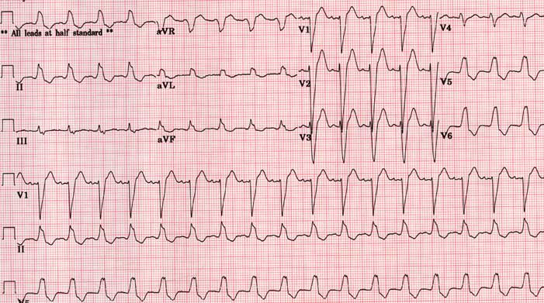

WBC 18.2 VBG Trop I 0.095
Hb 128 pH 7.21
Plt 360 pCO2 53
PO2 35
Na 132 HCO3 25
K 3.8
Cl 98
HCO3 27


