Section I: Scenario Demographics

Scenario Title: | Cardiac Arrest
Date of Development: | (31/10/2018)
Target Learning Group: | Juniors (PGY 1 – 2) Seniors (PGY ≥ 3) All Groups

Section II: Scenario Developers

Scenario Developer(s): | Krista Dowhos MD & Alim Nagji CCFP-EM
Affiliations/Institution(s): | McMaster University
Contact E-mail (optional): | Krista.dowhos@medportal.ca

Section III: Curriculum Integration

Learning Goals & Objectives
Educational Goal: | To practice managing cardiac arrest in the setting of a STEMI
CRM Objectives: | - Communicate effectively within an interdisciplinary team during a resuscitation  - Prioritize tasks such as medications, interventions, investigations and consultations in a critically ill patient  - Delegate tasks amongst team members
Medical Objectives: | - Recognize the critically ill patient and provide BLS care including high quality CPR  - Provide ACLS to a patient with cardiac arrest including recognizing shockable and non-shockable rhythms, and treating shockable rhythms with early defibrillation  - Provide post-cardiac arrest care in a patient with ROSC including targeted temperature management and identifying and treating reversible causes of cardiac arrest

Case Summary: Brief Summary of Case Progression and Major Events
A 65-year old man presents to the ED via EMS with chest pain. He is initially mildly hypotensive and tachycardic. An ECG will show an anterior STEMI. The team will need to activate the cath lab, which will be delayed by 20 minutes. The patient will go into VT with a pulse, and the team will need to provide synchronized cardioversion. The patient will then go into VFib arrest followed by VT arrest, and the team will need to perform CPR and defibrillate for both scenarios. The patient will subsequently go into a PEA rhythm, at which time the team should continue to give CPR, epinephrine and not defibrillate. Lastly, the patient will have ROSC and the team will need to provide post-ROSC care. The case ends with the cath lab calling to say they are ready for the patient.

References
Template from https://emsimcases.com
ECG from https://lifeinthefastlane.com
Chest x-rays from http://jetem.org

Section IV: Scenario Script

A. Clinical Vignette: To Read Aloud at Beginning of Case
A 65-year-old male presents to the ED from a local fitness centre via EMS with chest pain. He was given 325 mg ASA PO in the ambulance. He arrives alert and oriented, distressed and clutching his chest.
B. Scenario Cast & Realism
Patient: | Computerized Mannequin |  |  |  |  | Realism:  Select most important dimension(s) |  |  | Conceptual
 | Mannequin |  |  |  |  |  |  |  | Physical
 | Standardized Patient |  |  |  |  |  |  |  | Emotional/Experiential
 | Hybrid |  |  |  |  |  |  |  | Other:
 | Task Trainer |  |  |  |  |  |  |  | N/A
Confederates | Brief Description of Role
Paramedic | Provide a history of the patient’s condition and treatment in the field and in ambulance
C. Required Monitors
EKG Leads/Wires |  |  | Temperature Probe |  |  |  | Central Venous Line
NIBP Cuff |  |  | Defibrillator Pads |  |  |  | Capnography
Pulse Oximeter |  |  | Arterial Line |  |  |  | Other:
D. Required Equipment
Gloves |  |  | Nasal Prongs |  |  |  | Scalpel
Stethoscope |  |  | Venturi Mask |  |  |  | Tube Thoracostomy Kit
Defibrillator |  |  | Non-Rebreather Mask |  |  |  | Cricothyroidotomy Kit
IV Bags/Lines |  |  | Bag Valve Mask |  |  |  | Thoracotomy Kit
IV Push Medications |  |  | Laryngoscope |  |  |  | Central Line Kit
PO Tabs |  |  | Video Assisted Laryngoscope |  |  |  | Arterial Line Kit
Blood Products |  |  | ET Tubes |  |  |  | Other:
Intraosseous Set-up |  |  | LMA |  |  |  | Other:
E. Moulage
Diaphoresis spray

F. Approximate Timing
Set-Up: |  | 3 min |  | Scenario: | 15 min |  |  | Debriefing: |  | 20 min

Section V: Patient Data and Baseline State

A. Patient Profile and History
Patient Name: Daniel Cook |  |  |  |  |  | Age: 65 |  |  |  |  |  |  |  | Weight: 100 kg
Gender: M F |  |  |  |  |  | Code Status: Full code
Chief Complaint: Chest pain
History of Presenting Illness: This patient was at the gym, walking on the treadmill, and developed chest pain. He describes it as crushing and radiating to his jaw. He finds it hard to take a deep breath. He feels nauseous and sweaty. He occasionally gets mild chest pain when he works out, but says it is never this bad. He has otherwise been feeling well lately.
Past Medical History: |  | HTN |  |  |  |  | Medications: |  |  |  |  | Lipitor 40 mg PO daily
 |  | Hypercholesterolemia |  |  |  |  |  |  |  |  |  | Ramipril 5 mg PO daily
Allergies: None
Social History: ex-smoker (quit 20 years ago), drinks 7 beers per week, no recreational drugs.
Family History: Father had an MI at 70.
Review of Systems: |  | CNS: |  |  | Feels lightheaded, no focal neurological complaints
 |  | HEENT: |  |  | Jaw pain
 |  | CVS: |  |  | Chest pain described as retrosternal and “crushing” with radiation to radiating to jaw.
 |  | RESP: |  |  | “Hard to take deep breath”, no cough or hemoptysis
 |  | GI: |  |  | Nauseous, no vomiting
 |  | GU: |  |  | No complaints
 |  | MSK: |  |  | Generalized weakness |  |  |  |  |  |  |  | INT: |  | Diaphoretic
B. Baseline Simulator State and Physical Exam
No Monitor Display |  |  |  | Monitor On, no data displayed |  |  |  |  |  |  | Monitor on Standard Display
HR: 100/min |  |  | BP: 100/60 |  |  |  |  | RR: 20/min |  |  |  |  |  |  | O₂SAT: 90%
Rhythm: sinus |  |  | T: 37ºC |  |  |  |  | Glucose: 7 mmol/L |  |  |  |  |  |  | GCS: 15 (E5 V5 M5)
General Status: distressed, clutching chest, diaphoretic
CNS: | Cranial nerves 2-12 intact. Peripheral neurological exam normal.
HEENT: | No jaundice or central cyanosis, mucous membranes slightly dry
CVS: | Normal s1/s2, no murmurs or extra sounds
RESP: | GAEB, no crackles or wheezes on auscultation
ABDO: | Abdomen soft, non-tender, non-distended, no masses or HSM, no rebound tenderness
GU: | Normal
MSK: | ¾ strength in upper and lower extremities |  |  |  |  |  |  |  | SKIN: | Diaphoretic, no rashes, no mottling, no peripheral cyanosis.

Section VI: Scenario Progression
Scenario States, Modifiers and Triggers
Patient State | Patient Status | Learner Actions | Modifiers & Triggers to Move to Next State
1. Baseline State  Rhythm: sinus  HR: 100/min  BP: 100/60  RR: 20/min  O2SAT: 90%  T: 37ºC | Distressed, clutching chest, diaphoretic, GCS 15 | 1st round state 1:  -ABCs, IV, O2, monitor  -Apply defibrillator pads  -ECG (STEMI)  -Portable CXR (normal)  -Cap glucose (7.0)  -Labs  -250-500 cc IV bolus  - Activate cath lab (20 minute delay) | Modifiers  Changes to patient condition based on learner action  - Bolus given BP 105/65  - O2 provided O2SAT 94%  Triggers  For progression to next state  - After 3 mins, HR increase to 180 2. VT with a pulse
2. VT with a pulse  HR 180  BP 80/45  RR 7  O2SAT: 85% | Pulse present, patient drowsy, GCS 11 (E3 V3 M5) | -Synchronized cardioversion | Triggers  - Cardioversion or after 1 min 3.Vfib arrest
3. VFib arrest  HR ??  Rhythm: VFib  BP ??  O2SAT 75% | Pulseless, unresponsive | -High quality CPR with pulse check q2 mins  -Defibrillate  -Amiodarone 300 mg IV | Triggers  Defibrillation or after 3 min 4. VT arrest
4. VT arrest  HR 180  Rhythm: VT  BP ??  O2SAT 75% | Pulseless, unresponsive | -High quality CPR with pulse check q2 mins  -Defibrillate  -Amiodarone 150 mg IV  -Epinepherine 1 mg IV q3min | Triggers  Defibrilation or after 3 mins 5. PEA arrest
5. PEA arrest  HR ??  Rhythm: PEA  BP ??  O2SAT 75% | Pulseless, unresponsive | -High quality CPR with pulse check q2 mins  -Epinepherine 1 mg IV q3min | Triggers  - After 3 mins 6. ROSC
5. ROSC  Rhythm: sinus  HR: 60/min  BP: 105/60  RR: 9/min  O₂SAT: 92%  T: 36ºC | Pulses present GCS 7 (E1 V2 M4) | -Targeted temperature management (32-34 ºC; IV cold saline 2-3 mL/kg or cooling vest)  -Repeat ECG  -Consider intubation  -Post intubation CXR  -Heparin 5000 units IV  -Place NG  -Ticagrelor 180 mg NG  -Consider vasopressor to target MAP >65 (e.g. epinephrine 0.1-0.5 mcg/kg/min) | Triggers  After 2 mins cath lab ready for patient  END CASE

Section VII: Supporting Documents, Laboratory Results, & Multimedia

Laboratory Results
Labs will not be back before the case ends.

ECG showing anterior STEMI
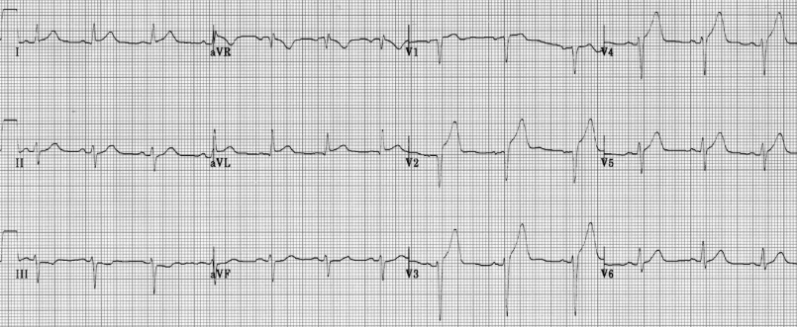
Portable CXR – normal 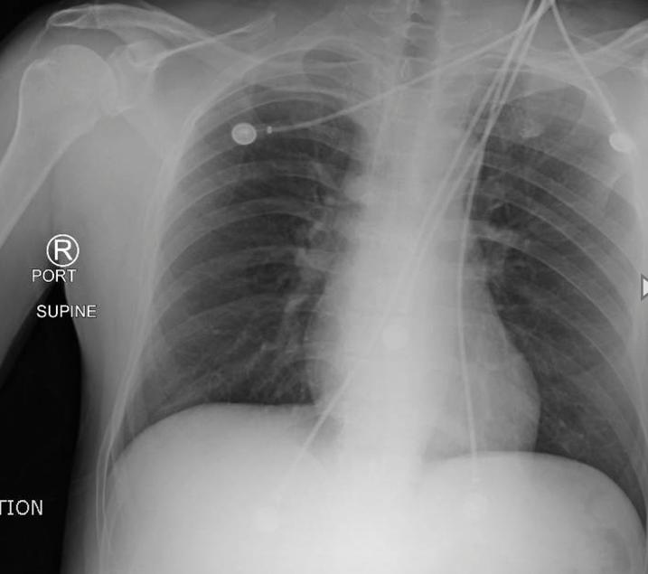 | Portable CXR – post-intubation  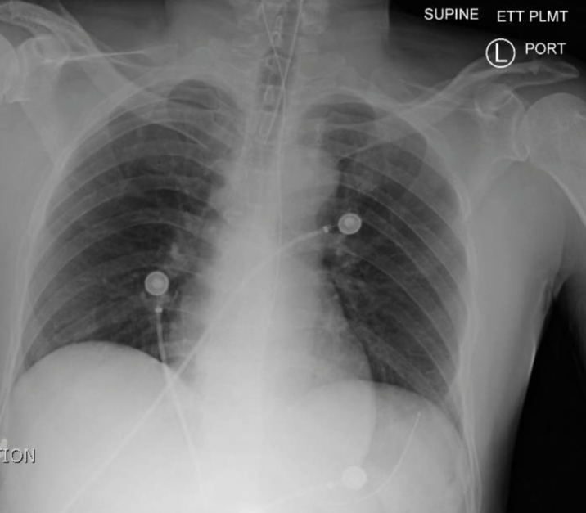

Section VIII: Debriefing Guide

General Debriefing Plan
Individual | Group |  | With Video | Without Video
Objectives
Educational Goal: |  | To practice managing cardiac arrest in the setting of a STEMI
CRM Objectives: |  | - Communicate effectively within an interdisciplinary team during a resuscitation  - Prioritize tasks such as medications, interventions, investigations and consultations in a critically ill patient  Delegate tasks amongst team members
Medical Objectives: |  | - Recognize the critically ill patient and provide BLS  - Provide ACLS to a patient with cardiac arrest  - Recognize shockable and non-shockable rhythms and treat shockable rhythms with defibrillation  - Provide appropriate post-cardiac arrest care in a patient with ROSC
Sample Questions for Debriefing
- What is your approach to the initial assessment and management of the critically ill patient (e.g. ABCs, IV/O2/monitor)?
- Describe the communication and team dynamic during the resuscitation. What do you feel went well? What do you feel could have been done better?
- What are the various rhythms a patient in cardiac arrest can have and how to do you manage them?
- What is your approach to post-ROSC care?
Reassess vital signs
Targeted temperature management
- Maintain temperature of 32-34 ºC
Optimize oxygenation and ventilation
- Consider intubation
- CXR to ensure proper ETT placement
- Keep end tidal CO2 30-40
- Use highest FiO2 until ABG available
Optimize cerebral perfusion/avoid and treat hypotension
- Target MAP >65 mm Hg
- Treat hypotension with vasopressors (e.g. epinephrine 0.1-0.5 mcg/kg/min)
Identify and treat reversible causes of cardiac arrest
- Hypovolemia
- Hydrogen ions
- Hypoxia
- Hyper/hypokalemia
- Hypothermia
- Trauma
- Tamponade
- Thrombus (pulmonary or coronary)
- Toxins
- Tension pneumothorax
Key Moments
Initial assessment and stabilization of the critically ill patient
Activation of the cath lab
Synchronized cardioversion of VT with a pulse
Unsynchronized defibrillation of VT arrest and Vfib
Continued CPR for PEA arrest
Administer post-ROSC care

