Top of Form

Queen’s University Simulation Scenario Template

Course: | SR Rounds, Tox II
Case Title: | Bupivicaine Overdose
Brief Case Description

An 87 year old woman presents to the ED with multiple lacerations, where a junior resident inadvertently overdoses the patient on Bupivicaine (a local anestheitc).
The patient proceeds to have seizures, and a VF cardiac arrest.
The students must utilize Lipid Emulsion and sodium bicarbonate to resuscitate the patient successfully
Searchable Keywords:
- Bupivicaine
- Intralipid

Target Audience: | SR Residents
Number of Participants: | 5
CanMeds Roles : |  | Medical Expert |  | Manager |  | Scholar
 |  | Communicator |  | Collaborator |  | Professional
 |  | Health Advocate
Objectives:
- Knowledge | To know the toxic dose of bupivacaine  To know the dose of intralipid, and understand its use as an antidote to bupicvicaine toxicity
- Skills

- Behaviour

Bottom of Form

Stem: Detailed description of exercise
Florence is an 87 year old woman who presents to the ED with multiple lacerations following a fall through a broken glass door. These lacerations require repair, and a junior resident uses bupivacaine as the local anesthetic. The patient is inadvertently overdosed, and subsequently has a generalized seizure, and then progresses to a VT with a pulse, then to VF arrest.
The students must administer Intralipid (lipid emulsion) at a dose of 1.5 ml/kg bolus (100cc). This bolus can be repeated during periods of cardiac instability. Then an infusion of 0.25ml/kg/min for 60 minutes.
If an ECG is performed, the initial ECG will show NSR with a markedly widened QRS (Na channel blockade). This should be treated with ampules of sodium bicarbonate.
Roles:
Script (for each role): | JR: [Runs into the room to get the attending]  “Help, Mrs. Jones is having a seizure!  I was suturing her wounds when she started to complain of feeling unwell, then she went unresponsive and is having a seizure”  [When asked how much Marcaine/Bupivaciane they used:]  “I used a lot. There were so many lacerations. I think I’m onto my 4th bottle”
Scenario Tips:
- Tips to future instructors to keep the scenario flowing.
- Anticipated difficulties

Scenario Details:
Demographics:  - Name:  - Age:  - Sex:  - BMI | Florence Jones  87  female  18
Chief Complaint: | Lacerations to her abdomen, arms, and legs after falling through a glass door that broke during the fall.  After receiving Marcaine, she suffers a seizure and then cardiac arrest
Past Medical History: | Hypertension  Early dementia – still active, and lives independently. Completely independent of her ADL/s
Medications: | HCTZ 25 mg po OD  ASA 81 mg po OD
Allergies: | None
Lab data: (provided if requested) | Link
Imaging: (provided if requested) | Link
ECG:  (provided if requested) | NSR with Wide QRS Complex – Indicative of sodium channel blockade

Initial Physical Examination Findings: (Normal if left blank)
Vital signs:
Temperature | 36.7
HR | 95
BP | 84/40
RR | 18
O₂ saturation | 90%RA
Finger stick glucose | 8.7
Weight (kg) | 46 kg
Cardiovascular:
Heart rate/rhythm | NSR
Heart sounds | Normal
JVP | Normal
Peripheral pulses | Normal
Evidence of cyanosis? | No
Diaphoresis | No
Other
Respiratory:
Respiratory rate/pattern | Normal
Accessory muscle use? | No
Lung sounds | Normal
Evidence of fatigue? | No
Other
Abdominal:
Visible signs of pathology? | No
Bowel sounds | Normal
Peritoneal signs? | No
Tenderness? | No
Hepatosplenomegaly? | No
Signs of ascites? | No
Other
Neurological:
Level of consciousness & Behaviour | Altered LOC, generalized seizure
Muscle tone | Generalized tonic/clonic seizure
Motor
Sensory
Reflexes
Other
Head/Ears/Eyes/Nose/Throat/Skin:
Visible abnormalities | no

Flow Table:
Time or Stage: | 0:00 | After NRB | After BZD/Propofol | After intubation | 5 minutes | 7 Minutes | After Intralipid & Defib
Heart rhythm: | NSR |  |  |  | VT | VF | NSR
Heart rate: | 95 |  |  |  | 130 | 0 | 118
Heart Sounds: | Normal |  |  |  | Normal
Blood pressure: | 84/40 |  |  |  | 68/30 | 0 | 70/40
Respiratory rate: | 18 |  |  |  | Vent
Respiratory Pattern: | Normal
O₂ saturation: | 90%RA | 93% NRB |  | 98% | 98% | 0
Temperature: | 36.7
Glucose | 8.7
Eyes: | Closed |  | Closed
Pupils: | Normal |  | Normal
Specific simulator dialogue: | None |  | Unresponsive
Other: | Seizure |  | Abort Seizure

Flow Diagram:
Insert specific scenario flow diagram showing pathways for anticipated actions. Each section of the diagram should correspond to a column on the Flow Table above.
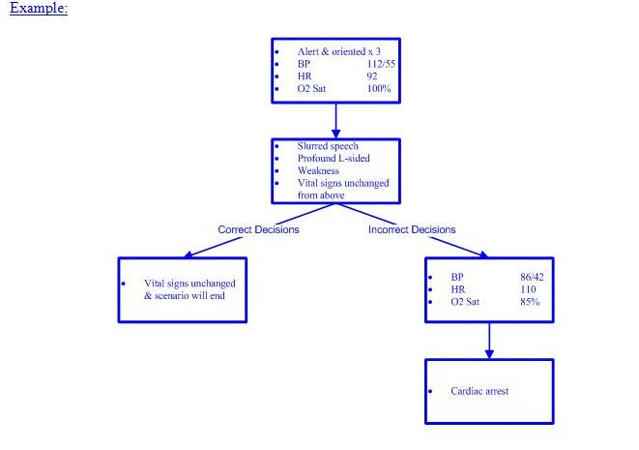

Simulator Requirements:
Environment: |  | ER
 |  | Hospital Ward
 |  | ICU
 |  | Other
Required simulator capabilities: |  | Adult
 |  | Child
 |  | Ability to talk
 |  | Ability to open and close eyes
 |  | Ability to change pupil size
 |  | Output of basic cardiorespiratory rhythms
 |  | Ability to change vital signs
 |  | Ability to perform CPR
 |  | Ability to deliver energy via LifePack
 |  | Ability to gain IV access
 |  | Ability to gain IO access
 |  | Ability to get 12 and 15 lead EKG’s
 |  | Ability to deliver drugs
 |  | Ability to ventilate
 |  | Ability to intubate
 |  | Ability to catheterize
 |  | Ability to needle decompress
 |  | Ability to insert chest tube
 |  | Ability to seize
 |  | Ability to simulate cyanosis
 |  | Other:
Task trainers required: |  | IV access trainer
 |  | IO access trainer
 |  | Lumbar puncture trainer
 |  | Central line access trainer (IJ, femoral, subclavian)
 |  | Chest tube trainer
 |  | Cricothyrotomy trainer
 |  | Pericardiocentesis trainer
 |  | Thoracotomy trainer
 |  | Other:
Communications Equipment: |  | One way wireless (confederate)
 |  | Two way wireless (confederate)
 |  | Overhead Speakers
 |  | Telephone
 |  | Pager
 |  | Other:

Moulage:

Describe any scenario-specific moulage on the diagram below:

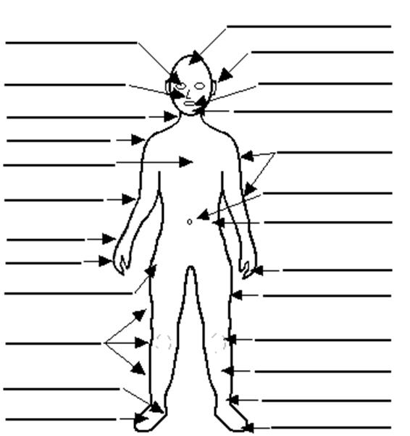

Mannequin Clothing

Hospital gown
Formal work attire
Casual attire
Athletic clothing
Other:

Equipment Required: |  |  |  |  |  | Quantity Required |  | Sizes Required  (if applicable)
Diagnostic/Monitoring: |  |  |  | Portable monitor
 |  |  |  | Thermometer
 |  |  |  | NIBP
 |  |  |  | Defibrillator
 |  |  |  | EKG
 |  |  |  | CXR
 |  |  |  | O₂ saturation probe
Airway: |  |  |  | Bag valve mask
 |  |  |  | Peak flow meter
 |  |  |  | Nasal cannula
 |  |  |  | Nebulizer
 |  |  |  | Non-rebreather mask
 |  |  |  | Mechanical ventilator
 |  |  |  | Oropharyngeal airway
 |  |  |  | Nasopharyngeal airway
 |  |  |  | Non-invasive positive pressure ventilation
 |  |  |  | Laryngoscope
 |  |  |  | Endotracheal tube
 |  |  |  | Syringe
 |  |  |  | Stylet
 |  |  |  | End tidal CO₂ detector (colorimetric)
 |  |  |  | End tidal CO₂ detector (capnographic)
 |  |  |  | Bougie
 |  |  |  | Glidescope
Vascular access: |  |  |  | Peripheral IV
 |  |  |  | Arterial line
 |  |  |  | Central line
 |  |  |  | PICC line
 |  |  |  | Swan Ganz catheter
 |  |  |  | Dialysis catheter
Resuscitation: |  |  |  | Crash cart
 |  |  |  | Trauma cart
 |  |  |  | Difficult airway cart
 |  |  |  | Cricothyrotomy tray
 |  |  |  | Chest tube tray
 |  |  |  | Pericardiocentesis tray
 |  |  |  | Chest tube tray
 |  |  |  | Urinary catheter tray
Other:
Fluids and Drugs |  |  |  |  | Volume, Concentration or Dose Required |  | Number of Units Required
IV Fluids: |  |  | NS
 |  |  | 0.45% NS
 |  |  | 3% NS
 |  |  | 2/3 1/3 NS
 |  |  | D5W
 |  |  | D5 ½ NS
 |  |  | Ringer’s lactate
 |  |  | Pentaspan
 |  |  | Other: Intralipid (100mL minibag filled with milk) |  | 100 cc |  | 2
Blood products: |  |  | 25% albumin
 |  |  | 5% albumin
 |  |  | pRBC’s
 |  |  | Platelets
 |  |  | Fresh Frozen Plasma
 |  |  | Cryoprecipitate
 |  |  | Factor VIII concentrate
 |  |  | Factor IX concentrate
 |  |  | Other:
Pre-filled drugs: |  |  | D50W
 |  |  | Epinephrine
 |  |  | Bicarbonate
 |  |  | Calcium chloride
 |  |  | Lidocaine
 |  |  | Atropine
 |  |  | Adenosine
 |  |  | Other:
Other drugs: |  |  | Fentanyl
 |  |  | Midazolam
 |  |  | Propofol
 |  |  | Etomidate
 |  |  | Ketamine
 |  |  | Succinylcholine
 |  |  | Roccuronium
 |  |  | Glucagon
 |  |  | Digoxin
 |  |  | Lasix
 |  |  | Nitrogylcerin
 |  |  | Labetelol
 |  |  | Other:

Audiovisual Needs:
Imaging: | (link to x-rays, CT scans, ultrasounds, MRI’s)
Bloodwork: | (link to bloodwork here)
EKG’s: | (link to EKG’s here)
Short didactic presentation: | (link to short presentation here – max 5 minutes)
Handouts: | (link to handouts here)
Simulator exercise file: | (link to simulator exercise file here)
References:
Required reading: | (link to required reading here)

Debriefing points:
- Knowledge | Link from objectives
- Skills | Link from objectives
- Behaviour | Link from objectives

Assessment:
- Knowledge  - Objective 1  - Objective 2  - Objective 3 | 1  1  1 | 2  2  2 | 3  3  3 | 4  4  4 | 5  5  5
- Psychomotor  - Objective 1  - Objective 2  - Objective 3 | 1  1  1 | 2  2  2 | 3  3  3 | 4  4  4 | 5  5  5
- Behaviour  - Objective 1  - Objective 2  - Objective 3 | 1  1  1 | 2  2  2 | 3  3  3 | 4  4  4 | 5  5  5
Global performance: | 1 | 2 | 3 | 4 | 5
- Critical action:
- Critical errors:
- Participants’ evaluation: | Link to evaluation for the session to be filled out by the participants

